Curriculum Vitae of Dr. Varsha Baste

Director- Baste Maternity Hospital &Pushpa Fertility Center
CEO & Founder - Cell Gen Anti Aging Center
Nashik, India.

Address: Baste Maternity Hospital,
H.P.T College Road,
Near Police Chowky,
Nashik 422005.
India

Email Address: varsha_baste@yahoo.in

Education:

Institution | Degree | Year | Field
Keil University, Germany | Diploma in Infertility | 2009 | Infertility
Fellowship in Foetal Medicine, UK | Clinical Fellow | 2006 | Ob/GYN
Bombay Hospital & Research Center,  Mumbai University, Mumbai. | MB. D.G.O | 1987 | Ob/GYN
B.J. Medical College, Pune, India | M.B.B.S | 1984 | Medicine

Work Experience & Recognition:

- Worked as medical officer in P.C.H Pimpalgaon (baswant) & civil hospital, Nashik for about 10 years.
- Was fortunate to get Late Dr. B. N. Purandare as my guide in OB GYN.
- Prestigious Dr. Anandibai Joshi awardee.
- Appreciated with special prize by Govt. of Maharashtra, India for extensive work in family planning for 4 consecutive years.
- Active participation in medical projects through local rotary club.
- Trained in art from various international institutes like –
- Brussels, Germany, etc.
- In private practice since 25 years in Nashik as Obstetrician & Gynecologist.
- Since last 15 years, started a state of art –advanced art center –Pushpa Fertility Center for human reproduction (IVF/ICSI).
- Participated & attended various national & international infertility & OBGYN conferences as faculty.
- Founder - Executive Committee of ISAR - Maharashtra chapter.
- Past President Nashik OBGY society in 2014.
- Chairperson PPIM Infertility conference in Nashik 2015.
- Felicitated by Icon Foundation with Tejaswani Award for distinguished women in 2013.
- CEO and Founder – Cell Gen Anti Ageing Center, Nashik (first in Western India) for stem cell therapy which is one of its kind using autologous stem cells with bone marrow, adipose tissue & blood components.

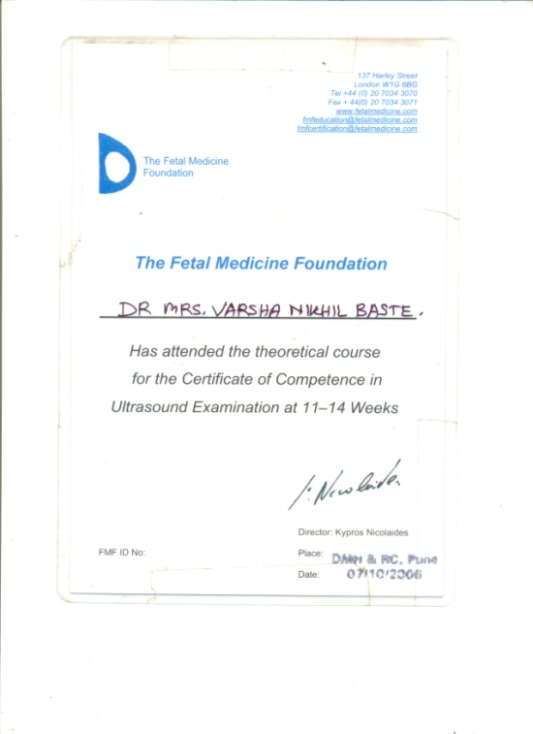
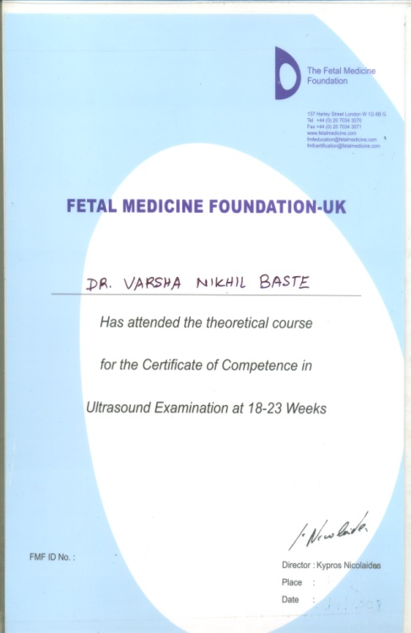
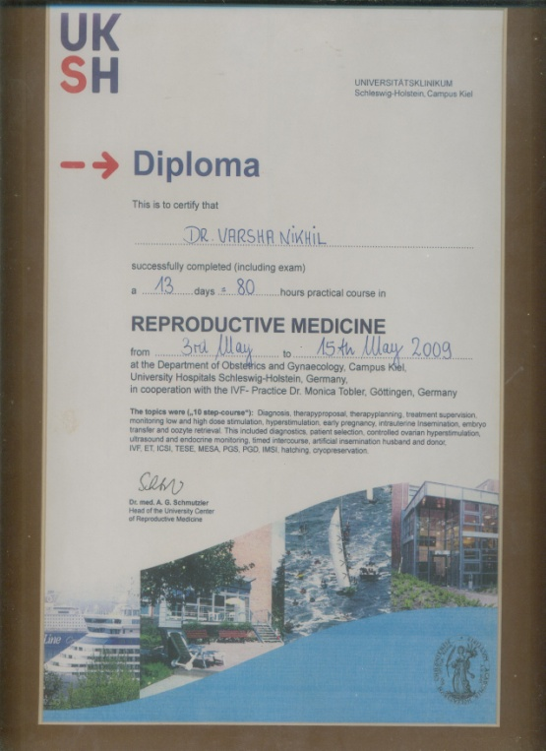
Certificates:
